Title: Sequential Circuit Design and Simulation
Intern Name: Lagisetty Vidya Charan
College: Mohan Babu University
Department: Electronics and Communication Engineering
Internship: VLSI Design Internship
- Introduction:
Sequential circuits are digital circuits whose outputs depend on the current inputs as well as the previous state of the circuit. Unlike combinational circuits, sequential circuits use storage elements and are generally controlled by a clock signal.
In this task, basic sequential circuits were designed and simulated using Verilog HDL and Xilinx Vivado. The implemented circuits include a D Flip-Flop, JK Flip-Flop, 4-bit Register, and 4-bit Binary Counter. Each design was verified through behavioral simulation using an appropriate Verilog testbench.
- Objective:
The objectives of this task are:
- To understand the basic operation of sequential circuits.
- To implement a D Flip-Flop using Verilog HDL.
- To implement a JK Flip-Flop and verify its different operating modes.
- To design a 4-bit register for data storage.
- To design a 4-bit binary counter.
- To create testbenches for each circuit.
- To verify the designs through behavioral simulation in Vivado.
- To analyze and document the resulting simulation waveforms.
- Tools Used:
Tool | Purpose
Verilog HDL | Hardware description and RTL implementation
Xilinx Vivado | Design entry and simulation
Behavioral Simulation | Functional verification
GitHub | Source-code and project documentation
- D Flip-Flop:
4.1 Description
A D Flip-Flop is a sequential storage element that captures the value present at its D input at the rising edge of the clock. The captured value is then maintained at the output until the next active clock edge.
The implementation uses a positive-edge-triggered clock.
  - Verilog Implementation
module d_flipflop(
input clk,
input D,
output reg Q
);

always @(posedge clk)
begin
Q <= D;
end
endmodule
  - Testbench
The testbench generates a periodic clock and applies different values to the D input to verify that Q captures D at the rising clock edge.
  - Simulation Result
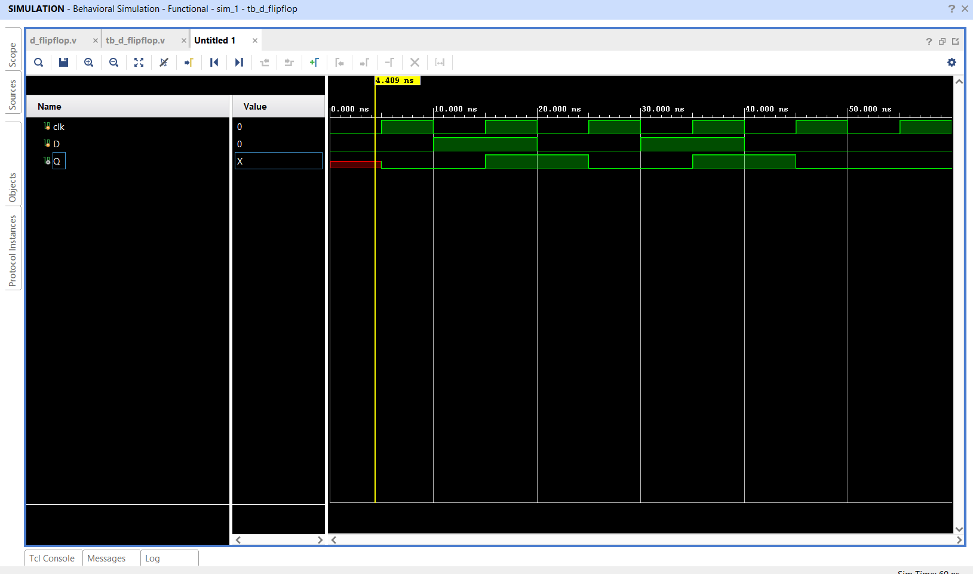
Figure 1: Behavioral simulation waveform of D Flip-Flop
  - Observation
The simulation verifies that the D Flip-Flop captures the input D at each rising edge of the clock. The output Q changes according to the value of D at the active clock edge and remains stored between clock edges.
The initial X observed in Q before the first valid clock operation is due to the absence of an initial/reset value.
- JK Flip-Flop:
5.1 Description
A JK Flip-Flop is a clock-controlled sequential circuit with two inputs, J and K. It provides four operating modes depending on the values of J and K. The task specifies the following operations.
J | K | Operation
0 | 0 | No Change
0 | 1 | Reset
1 | 0 | Set
1 | 1 | Toggle
  - Verilog Implementation
module jk_flipflop(
input clk,
input J,
input K,
output reg Q
);

always @(posedge clk)
begin
case ({J,K})
2'b00: Q <= Q;
2'b01: Q <= 1'b0;
2'b10: Q <= 1'b1;
2'b11: Q <= ~Q;
endcase
end

endmodule
  - Testbench
The testbench applies all four combinations of J and K:
00 → No Change
10 → Set
01 → Reset
11 → Toggle
This allows all operating modes to be verified.
  - Simulation Result
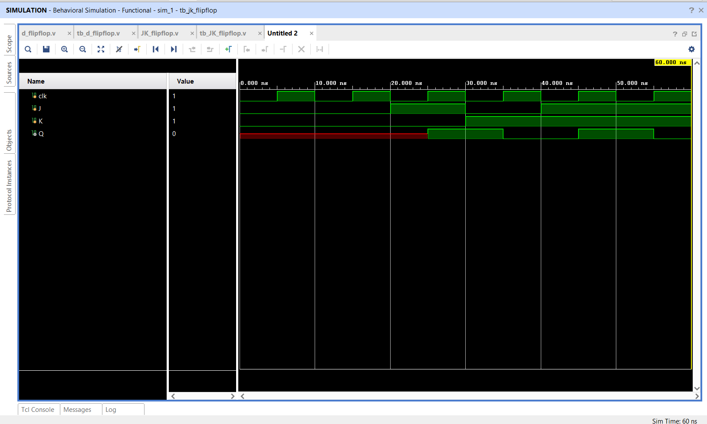

Figure 2: Behavioral simulation waveform of JK Flip-Flop
  - Observation
The simulation successfully verifies all four operating modes of the JK Flip-Flop. The output remains unchanged for J=0, K=0, becomes set for J=1, K=0, resets for J=0, K=1, and toggles for J=1, K=1.
- 4-bit Register:
6.1 Description
A register is a group of storage elements used to store binary data. In this task, a 4-bit register is implemented to store a 4-bit input value at the rising edge of the clock.
  - Verilog Implementation
module register4(
input clk,
input [3:0] D,
output reg [3:0] Q
);

always @(posedge clk)
begin
Q <= D;
end

endmodule
  - Testbench
The testbench applies the following 4-bit data values:
0000
1010
0101
1111
0011
The register captures each value on the rising edge of the clock.
  - Simulation Result
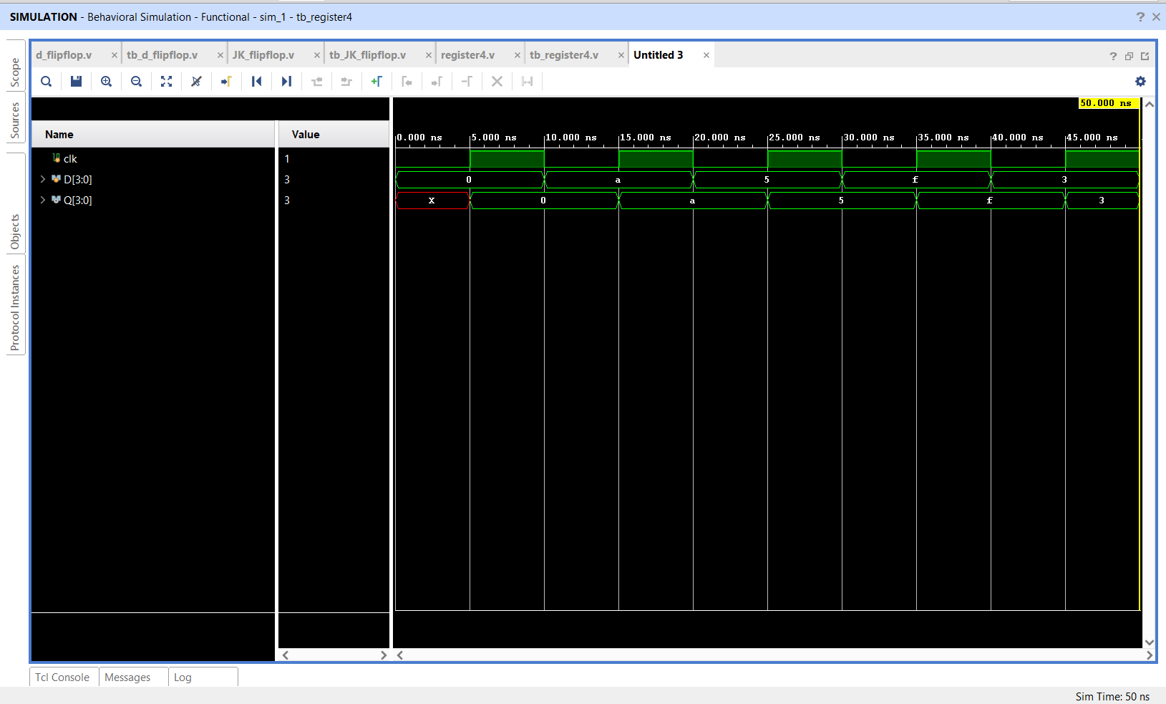

Figure 3: Behavioral simulation waveform of 4-bit Register
  - Observation
The simulation confirms that the 4-bit register successfully stores the input data at the rising edge of the clock.
The following values were successfully captured:
0000 → 1010 → 0101 → 1111 → 0011
The output remains stable between active clock edges
- 4-bit Binary Counter:
7.1 Description
A binary counter is a sequential circuit that changes its state according to the clock signal. The implemented 4-bit counter increments its value by one at every rising edge of the clock when reset is inactive.
A synchronous reset is included to initialize the counter to zero.
  - Verilog Implementation
module counter4(
input clk,
input reset,
output reg [3:0] count
);

always @(posedge clk)
begin
if (reset)
count <= 4'b0000;
else
count <= count + 1'b1;
end

endmodule
  - Testbench
Initially, reset is asserted to initialize the counter:
reset = 1
count = 0000
After reset is released, the counter increments on every rising edge
  - Simulation Result
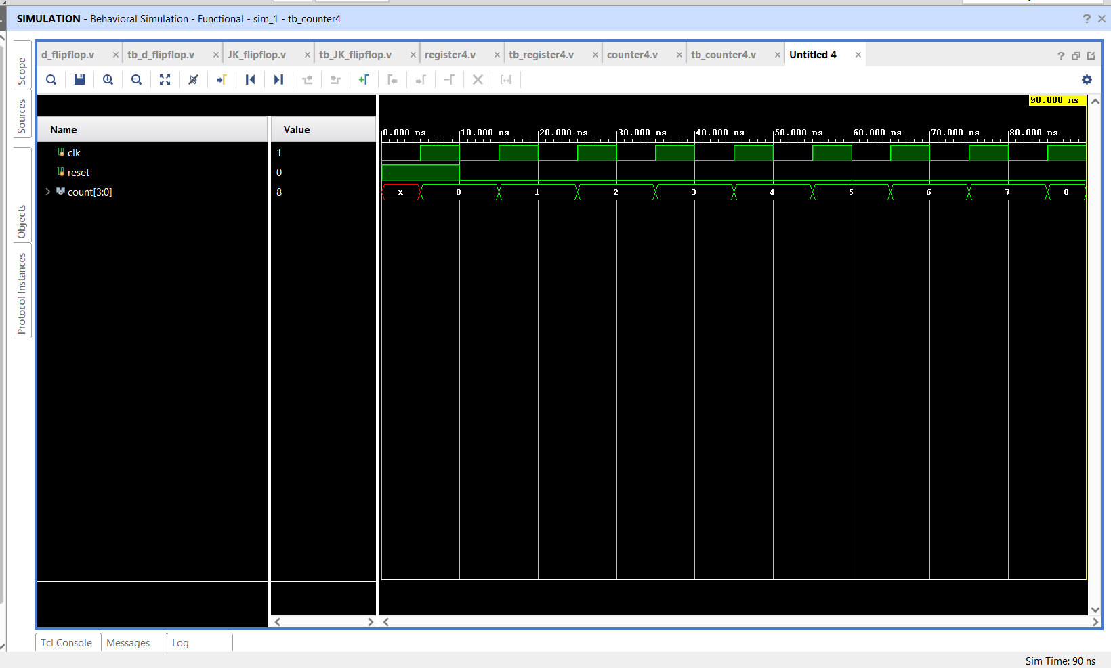
Figure 4: Behavioral simulation waveform of 4-bit Binary Counter
  - Observation
The simulation verifies the correct counting sequence:
0000
0001
0010
0011
0100
0101
0110
0111
1000
Thus, the counter successfully increments by one at each rising edge of the clock after reset is released. The task specifies this incrementing behavior for the binary counter.
- Overall Simulation Results:
Circuit | Inputs Tested | Simulation Result
D Flip-Flop | D and CLK | Verified
JK Flip-Flop | J, K, CLK | All four modes verified
4-bit Register | 4-bit D and CLK | Data captured correctly
4-bit Counter | CLK and RESET | Incrementing sequence verified
All four sequential circuits were successfully implemented in Verilog HDL and verified using behavioral simulation in Vivado.
- Conclusion:
The task successfully demonstrated the design and simulation of fundamental sequential circuits using Verilog HDL. A D Flip-Flop was implemented to demonstrate single-bit data storage, while the JK Flip-Flop was verified for its four operating modes. A 4-bit register was designed to store multi-bit data, and a 4-bit binary counter was implemented to increment its state on successive clock cycles.
The behavioral simulation waveforms confirmed that all four designs operate according to their intended functionality. This task provided practical experience in designing clock-driven sequential circuits, writing Verilog testbenches, running simulations, and analyzing waveform outputs.

